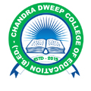
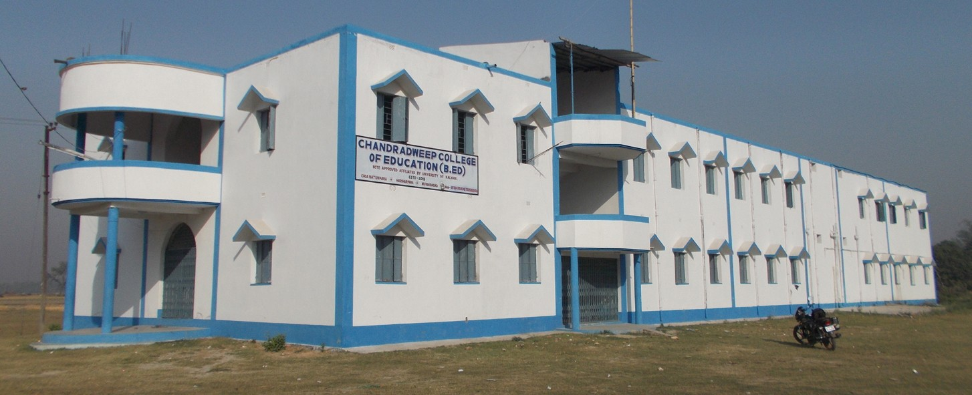
Two year D.El.Ed Course (ODL Mode)
For PBSSM Approved In- Service Para Teachers
(Primary & Upper Primary)

